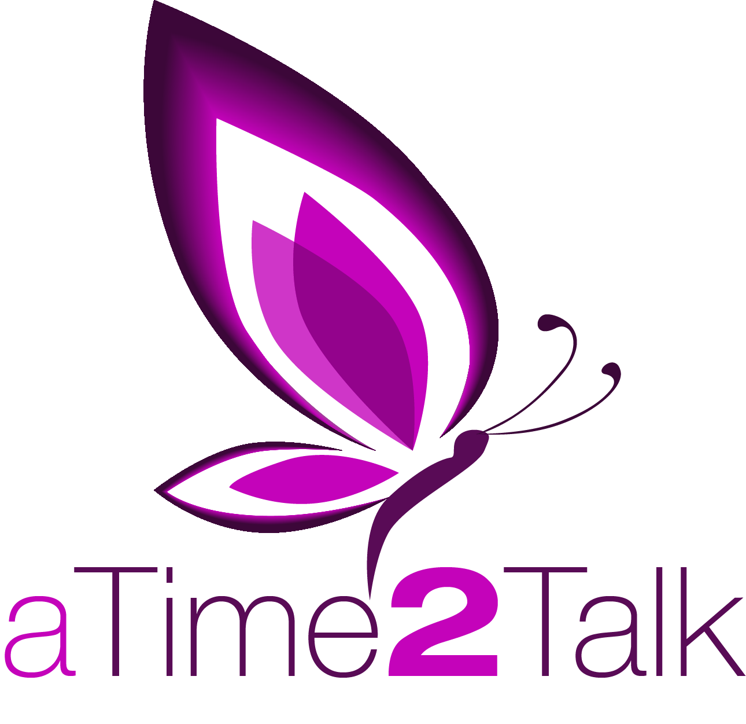 | Professional  Counselling and Listening Referral form  Tel: 07538 891 325

Details of person requesting counselling / listening service
Name:
Address:
 |  |  |  |  |  |  |  |  | Date of birth:
Home No: |  |  |  |  |  |  | Mobile:
Email address:
Best method of contact: |  |  |  |  | Home / Mobile / Email  Please circle all that apply
Is the person aware of the referral? |  |  |  |  |  |  |  | Yes / No / Self-referral
Can the counsellor contact direct? |  |  |  |  |  | Yes / No / Self –referral
Can the counsellor leave a message? |  |  |  |  |  |  |  |  | Yes / No
Counselling or Listening appointment required?
Is there a preferred day or time to contact?

Referrer details (leave blank if a self-referral)

Name:
Organisation name & address:

Contact No:
Email address:
Are you aware of any safeguarding issues? |  |  |  | Yes / No
If yes please give full details:

Page 2
Please indicate below which option your organisation is selecting:

Option 1 Option 2

(Option details on page 2)

Option 1

Assessment session – free of charge, with 6 sessions @ £15.00 per session. Where the client needs further sessions the 7th and subsequent sessions will be free of charge to the organisation, AT2T will fund these additional sessions.

An invoice for £90.00 will be submitted following the 6th session or earlier if less sessions are needed by the client. The invoice will reflect the number of sessions that the client attended at a cost of £15.00 per session.

Option 2

A one-off payment of £60.00.

The invoice will be submitted at the 2nd session that the client attends.

If the client only attends one session, then an amount of £25.00 will be invoiced to cover the assessment fee of £10.00 and the first session fee of £15.00.

If the client only attends the assessment, then an invoice will be submitted for £10.00 to cover the assessment session.

If you have any questions or queries, please do not hesitate to give us a call.

Referrer signature ……………………………….……. Date ……………

Please forward to the following email address:

atime2talk@hotmail.com

Please note that our emails are not encrypted, if you would like to password protect the document please contact us on 07538 891 325 so we can agree a password for the document.

