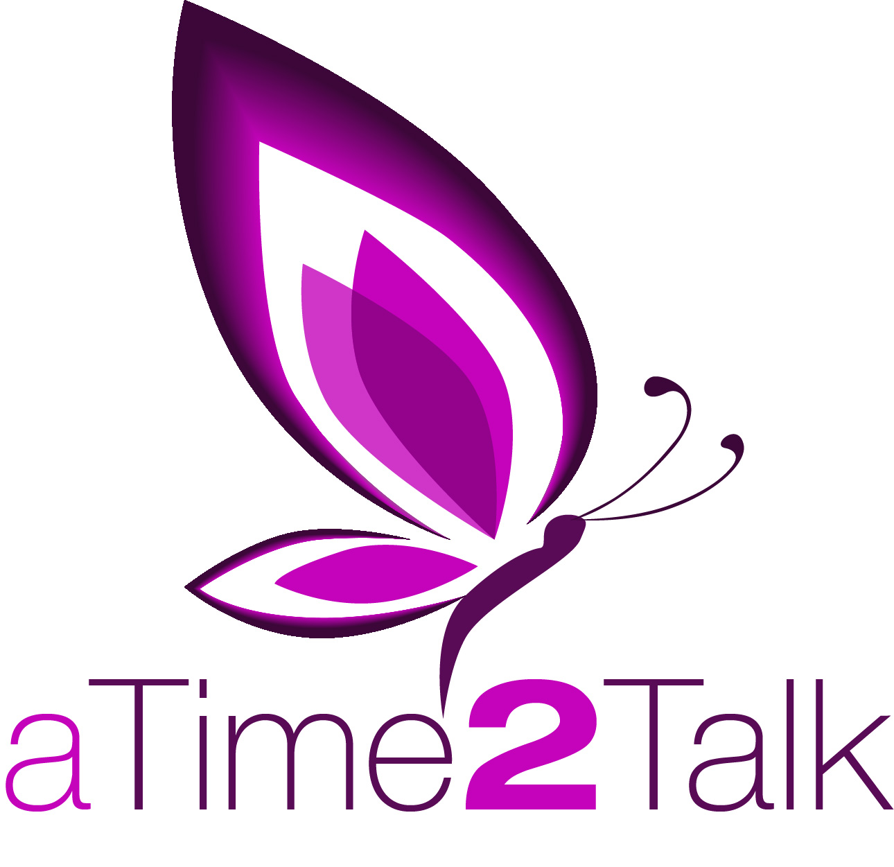

Counselling and Listening Referral Form

Details of person requesting counselling / listening service
Name:
Address:
 |  |  |  |  |  |  |  |  | Date of birth:
Home No: |  |  |  |  |  |  | Mobile:
Email address:
Best method of contact: |  |  |  |  | Home / Mobile / Email  Please circle all that apply
Is the person aware of the referral? |  |  |  |  |  |  |  | Yes / No / Self-referral
Can the counsellor contact direct? |  |  |  |  |  | Yes / No / Self –referral
Can the counsellor leave a message? |  |  |  |  |  |  |  |  | Yes / No
Counselling or Listening appointment required?
Is there a preferred day or time to contact?
If self-referral – how did you hear about A Time 2 Talk?

Referrer details (leave blank if a self-referral)

Name:
Organisation name & address:

Contact No:
Email address:
Are you aware of any safeguarding issues? |  |  |  | Yes / No
If yes please give full details:

Referrer signature ……………………………….……. Date ……………

Please forward to:
A Time 2 Talk, Disability North, The Dene Centre, Newcastle upon Tyne NE3 1PH

